Exploratory Data Analysis and Visualization of E-Commerce Transactions
E-Commerce Sales and Customer Analytics

Internship: YuvaIntern – Virtual Data Analysis Intern
Week: 3 – Exploratory Data Analysis and Visualization of E-Commerce Transactions
Dataset: UCI Online Retail Dataset
Student: Moksha
Project: E-Commerce Sales and Customer Analytics

1. Introduction
Exploratory Data Analysis (EDA) is an important step in data analytics. It helps understand a dataset's structure, identify patterns, examine relationships between variables, and discover potential data-quality issues before further analysis or modeling.
This project uses the cleaned Online Retail dataset prepared during Week 2 of the YuvaIntern internship. The dataset contains transaction records from an online retail business, including product descriptions, quantities, unit prices, invoice dates, customer identifiers, and countries.
The purpose of this week's work was to analyze the cleaned dataset using Python, calculate descriptive statistics, create meaningful visualizations, and interpret the results to identify useful business insights.

2. Objectives
The main objectives of this task were:
- To examine the structure and quality of the cleaned dataset.
- To calculate descriptive statistics for quantity, unit price, and revenue.
- To analyze monthly revenue trends.
- To identify the countries and products contributing the most recorded revenue.
- To visualize distributions and relationships between numerical variables.
- To identify important patterns, limitations, and opportunities for further analysis.

3. Dataset Description

The Online Retail dataset contains transaction-level records from an online retail business. Each row represents a transaction line associated with a product and invoice.
The analysis was performed using the cleaned dataset produced during Week 2.
Dataset characteristic| Result
Rows analyzed| 524,878
Countries represented| 38
Unique products| 3,922
Unique invoices| 19,960
Identified customers| 4,338
Start date| 1 December 2010
End date| 9 December 2011
Total recorded line revenue| 10,642,110.80
Average line revenue| 20.28
Median line revenue| 9.92
The revenue values are expressed in the dataset's original monetary units; no currency conversion was performed.

4. Tools and Libraries Used

Python: Used to execute the analysis and automate calculations and visualizations.
Pandas: Used to read the CSV file, inspect columns, convert data types, calculate descriptive statistics, group transactions, and summarize revenue.
Matplotlib: Used to create charts and customize titles, labels, axes, and layouts.
Seaborn: Used to create statistical visualizations, including a box plot and a correlation heatmap.
Visual Studio Code: Used as the development environment to write and execute the Python script.

5. Exploratory Data Analysis Methodology

The analysis followed these steps:
1. Loaded the cleaned CSV dataset into a Pandas DataFrame.
2. Checked the dataset dimensions and required columns.
3. Converted date and numerical columns to suitable data types.
4. Examined descriptive statistics for Quantity, UnitPrice, and Revenue.
5. Checked missing values in the available columns.
6. Grouped data by month, country, and product to identify major revenue contributors.
7. Generated charts to study trends, distributions, extreme values, and numerical relationships.
8. Recorded the key findings in a results text file.
The original cleaned dataset was retained. Chart-specific display limits were used where necessary to make visualizations easier to interpret.

6. Descriptive Statistical Analysis
The following statistics were obtained for Quantity, UnitPrice, and Revenue.
Statistic| Quantity| Unit Price| Revenue
Mean| 10.62| 3.92| 20.28
Median| 4.00| 2.08| 9.92
Standard deviation| 156.28| 36.09| 271.69
Minimum| 1.00| 0.00| 0.00
25th percentile| 1.00| 1.25| 3.90
75th percentile| 11.00| 4.13| 17.70
Maximum| 80,995.00| 13,541.33| 168,469.60
The mean is greater than the median for all three variables. This indicates that the distributions are influenced by relatively large values. The high standard deviations also show substantial variation between transaction lines.

The maximum quantity, unit price, and revenue values are considerably higher than their respective medians. These extreme observations deserve further investigation to determine whether they represent legitimate bulk purchases, unusual transactions, or data-quality issues.

7. Visualization and Interpretation
7.1 Monthly Revenue Trend
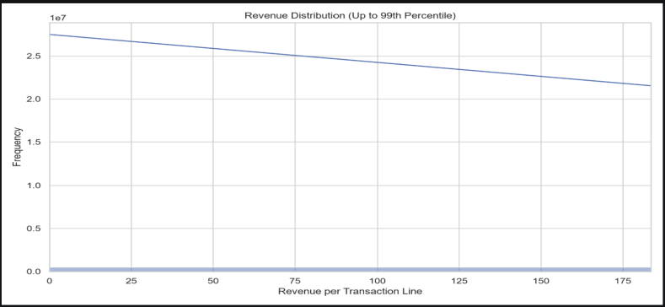
Figure 1: Monthly Revenue Trend

The monthly revenue chart was used to understand how recorded transaction-line revenue changed over time.
November 2011 recorded the highest monthly revenue, amounting to 1,503,866.78. This indicates that November was the strongest month in the analyzed dataset according to the revenue calculation used.
The trend can help identify periods of increased business activity and guide further investigation into seasonal demand, promotions, or customer purchasing behavior. However, the chart alone cannot establish the reason for the increase.

7.2 Revenue by Country
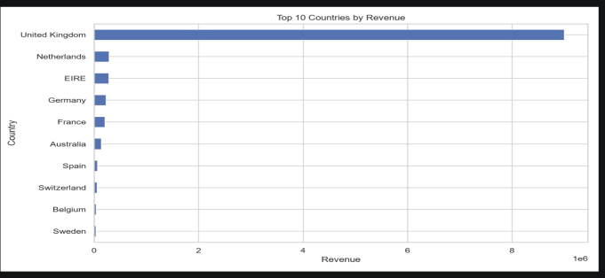
Figure 2: Top Countries by Revenue

The country-level visualization identified the United Kingdom as the largest contributor, with recorded revenue of 9,001,744.09.
This result indicates that the United Kingdom dominates the revenue distribution in the analyzed dataset. The business could examine its customer base, product demand, and order patterns in this market while comparing other countries to identify opportunities for growth.
The results describe the prepared dataset and should not be interpreted as a complete representation of all original transactions.
7.3 Revenue Distribution
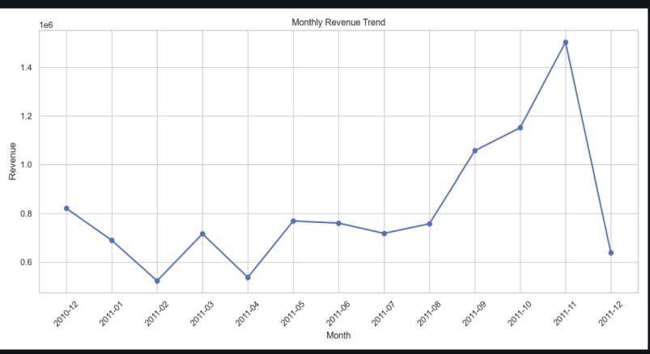
Figure 3: Distribution of Transaction-Line Revenue

The revenue histogram was used to examine how transaction-line revenue values were distributed.
The descriptive statistics show that the mean revenue of 20.28 is greater than the median of 9.92. This suggests a right-skewed distribution, where a relatively small number of high-value transactions increase the mean.
Understanding this distribution is important because the average alone may not represent a typical transaction. The median provides an additional measure of the central value.
7.4 Quantity Distribution
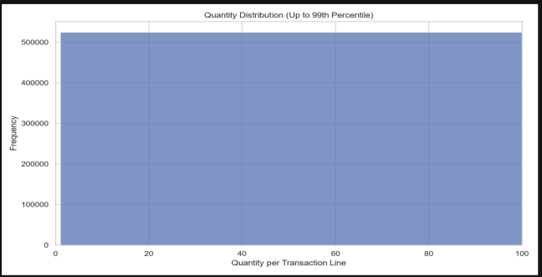
Figure 4: Distribution of Product Quantities
The quantity histogram helps show how many products are typically included in individual transaction lines.
The median quantity was 4, while the mean was 10.62. The maximum quantity was 80,995, indicating that some observations have exceptionally high quantities compared with typical transactions.
This pattern suggests that further investigation of bulk purchases and extreme values would be useful. A chart that limits the displayed range can make the main distribution easier to see without removing observations from the underlying dataset.
7.5 Unit Price Box Plot
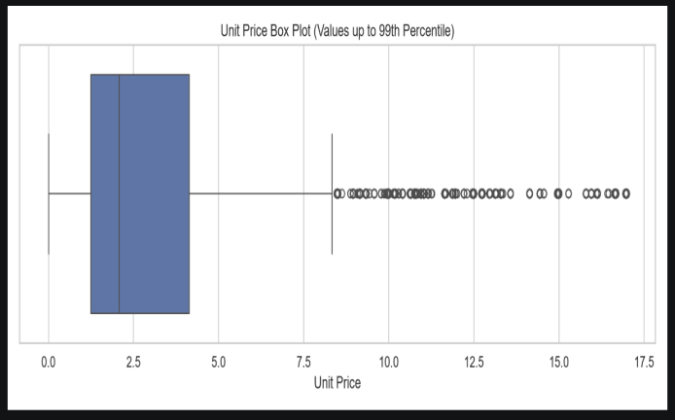
Figure 5: Unit Price Distribution and Extreme Values

The box plot was used to examine the spread of unit prices and identify unusually high values.
The median unit price was 2.08, whereas the maximum was 13,541.33. This large difference indicates the presence of extreme values that can affect summary statistics and visual interpretation.
Such observations should be checked against product information and transaction details before deciding whether they should be excluded from later analyses.
7.6 Quantity and Revenue Relationship
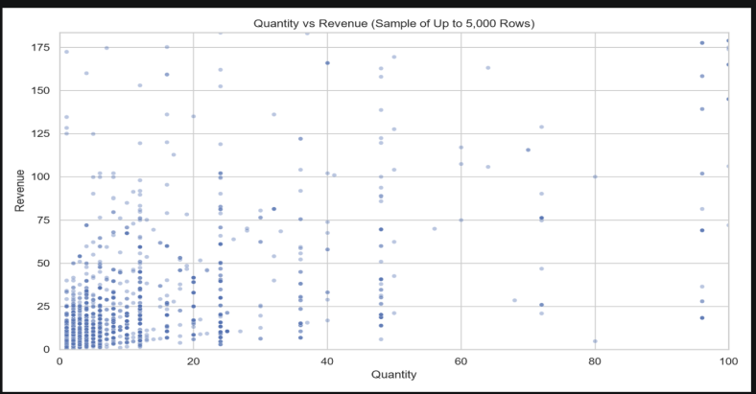
Figure 6: Quantity versus Revenue
The scatter plot was used to investigate the relationship between the quantity of products and transaction-line revenue.
The calculated correlation coefficient between Quantity and Revenue was 0.907, indicating a strong positive linear association. In general, larger quantities tend to be associated with higher revenue values.
This relationship is consistent with the expectation that selling more units can increase transaction value. However, the relationship is not proof of causation, and revenue also depends on unit price and the composition of each transaction.
7.7 Correlation Heatmap
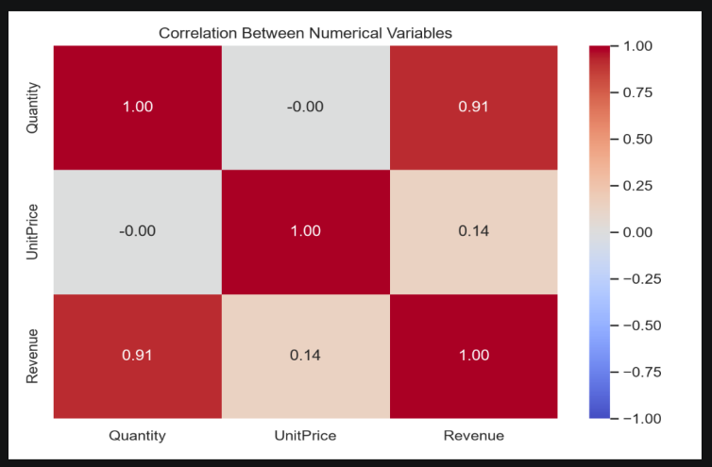
Figure 7: Correlation Heatmap of Numerical Variables

The correlation heatmap summarizes the linear relationships between the numerical variables included in the analysis.
The correlation between UnitPrice and Revenue was 0.137, indicating a weak positive linear association in the analyzed data.
The relationship between Quantity and Revenue was much stronger at 0.907. These results suggest that quantity has a stronger linear association with revenue than unit price in this dataset.
Correlation coefficients measure linear association and do not establish cause-and-effect relationships.
7.8 Top Products by Revenue
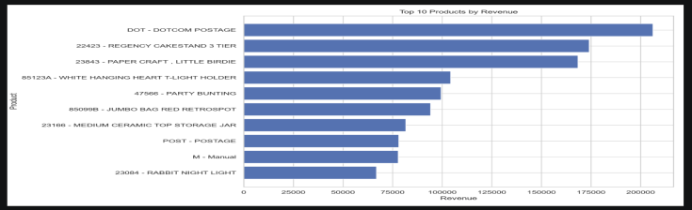
Figure 8: Top Products by Revenue

The product-level analysis identified DOTCOM POSTAGE (StockCode: DOT) as the highest-revenue product, with recorded revenue of 206,248.77.
This result highlights the importance of examining product-level performance instead of relying only on overall revenue totals. Further investigation could compare product descriptions, order frequency, quantities, and revenue contribution to understand the factors behind this result.
7.9 Top Customers by Revenue
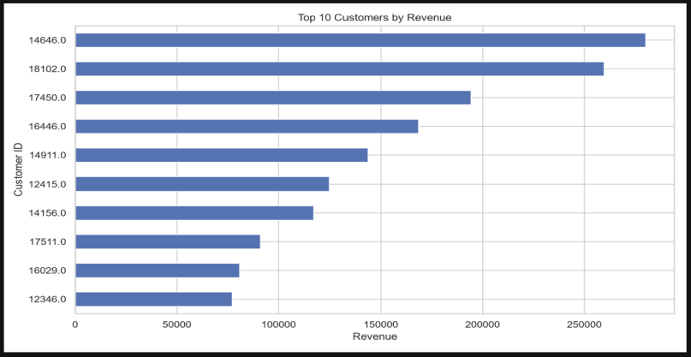
Figure 9: Top Customers by Revenue

The customer-level visualization was created to identify customers contributing the highest recorded revenue among transactions with available customer identifiers.
This analysis can help a business investigate purchasing patterns and customer value. However, 132,186 rows have missing CustomerID values, so customer-level results may not represent every transaction in the dataset.

8. Missing Values and Data Limitations
The missing-value analysis showed that CustomerID was the only listed column with remaining missing values.
Column| Missing values
CustomerID| 132,186
All other analyzed columns| 0
The missing CustomerID values represent an important limitation for customer-level analysis. Transactions without customer identifiers cannot be reliably assigned to individual customers.

The dataset had already undergone cleaning during Week 2. Consequently, the Week 3 findings describe the prepared dataset of 524,878 rows rather than every record in the original dataset.
Extreme values remain in the cleaned dataset used for this analysis. They may influence means, correlations, and visualizations, so they should be interpreted carefully.

9. Key Findings
The main findings from the analysis were:
1. The dataset contained 524,878 rows, 3,922 unique products, 19,960 unique invoices, and 38 countries.
2. November 2011 recorded the highest monthly revenue at 1,503,866.78.
3. The United Kingdom was the largest country-level revenue contributor at 9,001,744.09.
4. DOTCOM POSTAGE was the top product by recorded revenue at 206,248.77.
5. Quantity and revenue had a strong positive correlation of 0.907.
6. Unit price and revenue had a weak positive correlation of 0.137.
7. The mean values being higher than the medians indicate that the numerical distributions are influenced by high-value observations.
8. Missing customer identifiers limit the completeness of customer-level analysis.

10. Challenges and Learning Outcomes
One challenge was working with a relatively large CSV file containing more than half a million transaction lines. The analysis required efficient data loading, grouping, and numerical calculations.
Another challenge was interpreting distributions containing extreme values. Histograms and box plots helped make the spread and unusual observations easier to understand.
The task also demonstrated the importance of selecting suitable visualizations. Line charts are useful for examining trends over time, bar charts help compare categories, histograms show distributions, scatter plots explore relationships, and heatmaps summarize correlations.
Through this task, I gained practical experience in using Pandas, Matplotlib, and Seaborn for exploratory analysis and communicating results through visualizations.

11. Reflection and Next Steps
This task improved my understanding of how raw transaction records can be converted into meaningful analytical findings. It also demonstrated why data quality, missing values, and extreme observations must be considered before drawing conclusions.
The next stage of the project could include customer segmentation, monthly sales comparisons, product performance analysis, and identification of repeat purchasing behavior. Additional investigation of missing customer identifiers and extreme transaction values would improve the reliability of future analyses.
The findings could also be extended into an interactive dashboard using Power BI or Tableau.

12. Conclusion
The Week 3 exploratory data analysis successfully examined the cleaned Online Retail dataset using Python. Descriptive statistics and visualizations revealed monthly revenue patterns, the leading country and product by recorded revenue, the distribution of transaction values, and relationships between numerical variables.
The results demonstrate the value of exploratory data analysis in identifying patterns and generating questions for further business investigation. At the same time, missing customer identifiers and extreme observations highlight the need for careful interpretation.
Overall, this task strengthened my practical skills in data analysis, statistical summaries, visualization, and communicating analytical findings.

13. References
1. UCI Machine Learning Repository. Online Retail Dataset. https://archive.ics.uci.edu/dataset/352/online+retail
2. Pandas Documentation. https://pandas.pydata.org/docs/
3. Matplotlib Documentation. https://matplotlib.org/stable/
4. Seaborn Documentation. https://seaborn.pydata.org/

